Star Blaze

Star Blaze Program:
© 1983 Greg Zumwalt.
Licensed to Tandy Corporation
All Rights Reserved.
All portions of this software are copyrighted and are the proprietary and trade secret information of Tandy Corporation and/or its licensor. Use, reproduction or publication of any portion of this material without the prior written authorization by Tandy Corporation is strictly prohibited. The license for using this software is printed in the front of this manual.
Star Blaze Program Manual:
© 1983 Tandy Corporation
All Rights Reserved.
Reproduction or use, without express written permission from Tandy Corporation, of any portion of this manual is prohibited. While reasonable efforts have been taken in the preparation of this manual to assure its accuracy, Tandy Corporation assumes no liability resulting from any errors or omissions In this manual, or from the use of the information contained herein.

Introduction
Star Blaze is a new adventure in space exploration for your TRS-80 Color Computer. As the commander of a patrol ship, you are responsible for defending the 64 sectors of your galaxy. Aliens are attacking the galaxy, trying to destroy the fuel and repair stations set up in several sectors. You must hunt down the aliens and destroy them before they ruin the galaxy's supply stations. Your patrol ship, superior in speed, maneuverability, and attack power, is your best ally in the fight against the aliens.
We suggest that you read through this manual before trying to play Star Blaze. By reading before playing, you learn more about the choices and strategies involved and increase your chances of a successful mission on your first try. Good luck!

Required Equipment
To play Star Blaze, you need the following equipment:
• A standard television (color television recommended)
• A TRS-80 Color Computer with at least 16K memory
• A joystick

Setting Up
Make sure that the right joystick is properly connected to the computer. Tune the television to Channel 3, and adjust the volume to a comfortable level.
Next, insert the Star Blaze Program Pak™, label side up, into the slot on the right side of the computer.
Note: Be sure that the Color Computer is off before inserting or removing the Program Pak.
Turn on the computer. The opening screen of Star Blaze appears.
The screen is divided into three sections: the blue sky (displaying the copyright notice), the green ground (showing your patrol ship and several aliens), and the control panel.
The control panel gives most of the information important for a successful mission. The blue bars on the left of the panel are your energy gauges, indicating the supplies you have left. The energy gauges are:

F = Fuel S = Shield Energy
T = Torpedoes A = Radar Energy
The red rectangle on the control panel is your radar screen. The blinking dot represents your patrol ship. The moving dots represent aliens. Your two spare ships and the score are on the right side of the control panel.
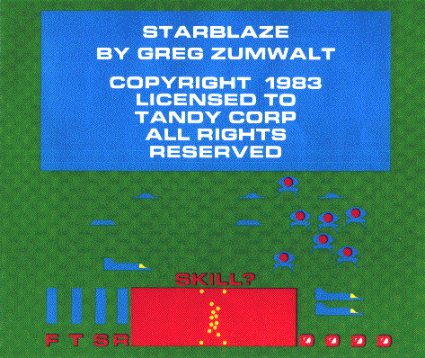
Choosing a Skill Level
A question appears above the control panel-SKILL? You have a choice of eight skill levels. Level 1 is the easiest, and Level 8 is the hardest. You may want to start at Level 1 and when you're comfortable using the joystick, work up to Level 8.
To choose a skill level, press the number key that is the same as the skill level at which you want to play. Once you've chosen a skill level, the game begins.
Playing the Game

Use the joystick to maneuver your ship up, down, left, and right. Fire a torpedo by pressing the fire button on the joystick.
As you fly across the planet, check the radar (the red rectangle) for approaching aliens. A message appears above the panel when an alien is corn-. ing within firing range. When the alien is between the white range dots on the radar screen, you will be able to see it. Maneuver your ship and fire at It until it is destroyed.

Your patrol ship is equipped with an invisible shield that protects it from alien attacks. However, shield power is limited. Each time an alien torpedo hits the shield, the shield becomes weaker. You can see your shield energy level by checking the S gauge on the control panel. If your ship collides with an alien, your shields are completely destroyed. If another alien manages to hit you before you can restore shield energy, your ship explodes, If your ship is destroyed, press the fire button and use one of the spare ships.

The Galaxy Map
If you destroy all aliens attacking a sector, the message above the control panel displays SECT CLR (for “Sector Clear”). You also see this message if you are flying in a sector not under alien attack. When no aliens threaten, you should fly to another sector to defend it. To do this, check the galaxy map.
Press [M], and the galaxy map appears. It shows the 64 sectors of the galaxy as colored boxes and looks similar to this:

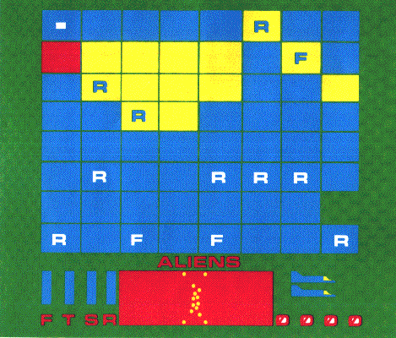
Here is your guide to the galaxy map:

Blue box No aliens in sector
Yellow box 1-15 aliens in sector
Red box More than 15 aliens in sector
R in box Repair station in sector
F in box Fuel station in sector
Blinking box Your location in galaxy
At the galaxy map, pressing [M] returns you to the game screen at the sector you were in previously. To travel to another sector, press ↑, ↓, ←, or → to move the small, blinking cursor to another sector. When you arrive at the sector you want, press [W] (warp speed) to return to the game screen at the new sector. Be careful! You can be attacked while you study the map.
When you return to the game screen, your ship is traveling at warp speed (the maximum speed at which the ship can fly). To properly defend the sector, you must slow down to normal cruising speed. Do this by moving the joystick In the opposite direction from which your ship Is moving. This slows you down and lets you safely continue your patrol.
Restocking Supplies
As you play, check your energy gauges for the amounts of supplies remaining. You need to restock supplies when your shield energy is low or when you need more torpedoes, fuel, or radar energy. A message above the control panel warns you when you are low on any supply by displaying the name of the supply you need.
To restock, display the galaxy map (by pressing [M] and find a sector showing either R or F. A Repair station contains torpedoes, shield energy, and radar energy. A Fuel station contains only fuel.
Move to the sector with supplies you need, and press [W] to return to the game screen. Remember that you are now flying at warp speed, so you need to slow down. Otherwise, you might miss the Repair or Fuel station! You know when you are approaching a station by a flashing dot at the bottom of the radar screen.
Stations are located on the ground and look like

When you see the station, approach it very slowly, and try to come in contact with it. Docking takes great skill and lots of practice. You might have to “bump” into the station several times before you successfully dock your ship. Once you do, the message above the control panel shows DOCKED.
Be careful! You are not warned of approaching aliens while you are restocking supplies. Once your energy gauges show full, leave the station and continue your mission.
Strategy
The following few hints should help improve your game. Try them anytime you play.
You can fly at warp speed anytime you like by pressing [W]. At warp speed, you use no fuel and cannot be attacked by aliens. Flying at warp speed takes you to another sector. You may want to check the galaxy map to see where you are. Remember that you should slow down If you want to dock at a station.
Since the mission of the aliens is to destroy energy stations, they constantly move toward sectors with stations. Naturally, the more aliens in a sector, the faster the stations are destroyed. A wise move is to travel to sectors under attack by the most aliens.
Scoring
You receive 50 points for each alien you destroy. After you destroy 64 aliens, you are awarded a free patrol ship. However, you are limited to a maximum of three ships at one time, including spares.
Colliding with an alien destroys the alien but earns no points.

Ending the Game
The game ends when all your patrol ships or all of the aliens are destroyed. You can see your total score and are given a rating from Fleet Command.
Under 1000 points - Garbage Scow
Over 1000 points - Flight Engineer
Over 2000 points - First Officer
Over 3000 points - Ship Captain
Over 4000 points - Fleet Commander

To play a new game or to start over during a game, press [R] and select a skill level. To stop playing Star Blaze, turn off the computer first, then the television, and remove the Program Pak from the computer. Always store your Program Pak in its protective box.
Good luck in your mission, and remember - the aliens are watching every move you make!

